1. Introduction

1.1 What is an LLM?
LLM stands for Large Language Model. It is a very powerful AI that was trained on billions of sentences from the internet, books, and code. It can understand and generate human language just like a person would.

Famous LLMs you already know:
ChatGPT — made by OpenAI
Gemini — made by Google
Claude — made by Anthropic
LLaMA — made by Meta (open-source, free to use)

Simple analogy: An LLM is like a very well-read person who has read the entire internet. Ask it anything and it gives you an answer — in your language, in seconds.

1.2 What is a Chatbot?
A chatbot is a program that lets you have a conversation with an AI. You type a message, the AI reads it and sends back a reply — just like WhatsApp, but the other person is an AI.
- Customer support chat on a website — a chatbot is usually handling it.
- Ask a question → get an instant answer, 24 hours a day.
- In this project, we will build one ourselves!

2. What is LLM Integration?

LLM Integration simply means connecting your own app or website to an AI model using an API. You do not build the AI — you just plug into it, like connecting a plug to a socket.

One-line idea:
Frontend → API Call → LLM → Response → Show on Screen

2.1 Real-Life Example
Imagine a travel website. When you type 'Best places to visit in Goa in December', the website sends that message to an LLM API and shows the reply on your screen. That connection is LLM Integration.

Without LLM Integration | With LLM Integration
You write all Q&A manually. | AI answers any question automatically.
Hard to update content. | Always up-to-date with LLM knowledge.
Can only answer pre-written questions. | Understands any new question in real time.

3. What is Prompt Engineering?

3.1 Simple Definition
A prompt is the message or instruction you send to the AI. Prompt Engineering means writing that message very carefully so the AI gives you the best possible answer.
Simple analogy: Prompt = Instructions to AI. If you give vague instructions, you get vague answers. If you give clear instructions, you get perfect answers.

3.2 Why Prompts Matter
- The AI has no idea who you are or what you want — the prompt tells it everything.
- A bad prompt → confusing, irrelevant, or wrong answer.
- A good prompt → accurate, focused, and helpful answer.

3.3 Bad Prompt vs Good Prompt

Type | Prompt | What Happens
❌ Bad Prompt | Tell me about Python. | AI gives a 5-paragraph essay about everything in Python — too long, not useful.
✅ Good Prompt | In 3 bullet points, explain Python for-loops to a beginner student. | AI gives a short, focused, beginner-friendly answer.

Pro tip: Always tell the AI WHO it is + WHAT to do + HOW to reply.
Example: "You are a helpful coding tutor. Explain recursion in 3 simple lines."

4. Project Idea

We will build a chatbot web application using Next.js. The user types a question, the app sends it to an LLM API, and the answer appears on the screen — word by word (streaming).

Project Summary:
Name: AI Chatbot with Streaming Responses
Frontend: Next.js (React-based web framework)
AI Model: OpenAI GPT / Google Gemini / Anthropic Claude
Feature: Streaming — response appears word-by-word like ChatGPT
Cost: Free API tier available for all three services

4.1 What the User Sees
- User opens the chatbot page in a browser.
- User types a question and clicks 'Send'.
- The response starts appearing word by word.
- The full answer is shown once complete.
- User can keep chatting — conversation history stays on screen.

5. Tools Used

5.1 Next.js
Next.js is a popular web framework built on top of React. It lets you build fast websites and also create backend API routes — all in one project. We use it to build both the chat UI and the server logic.

5.2 LLM API (Choose One)
API Provider | Model Name | Free Tier | Best For
OpenAI | gpt-4o-mini | Yes (limited) | Most popular, best quality
Google | gemini-1.5-flash | Yes (generous) | Free and fast for students
Anthropic | claude-haiku-4-5 | Yes (limited) | Safe and focused responses

5.3 Fetch API
The Fetch API is built into JavaScript and Next.js. We use it to send the user's message to the LLM and receive the response back. No extra library needed.

5.4 Node.js (Optional Backend)
Next.js has built-in API routes so you do not need a separate Node.js server. But if you want more control, you can add one. For this project, Next.js API routes are enough.

6. LLM API Integration

6.1 How to Get an API Key
- Go to platform.openai.com (or ai.google.dev for Gemini).
- Create a free account.
- Go to API Keys section → click 'Create new key'.
- Copy the key and store it safely — never share it publicly!
- In your Next.js project, add it to a .env.local file.

# .env.local file — store your key here
OPENAI_API_KEY=sk-your-key-here

6.2 Basic API Call — Send a Prompt, Get a Response
This is the core of the project. We send the user's message to the API and print the reply.

// pages/api/chat.js — Next.js API route
import OpenAI from 'openai';
const openai = new OpenAI({ apiKey: process.env.OPENAI_API_KEY });
export default async function handler(req, res) {
const { message } = req.body; // get user's message
const reply = await openai.chat.completions.create({
model: 'gpt-4o-mini',
messages: [{ role: 'user', content: message }],
});
res.json({ answer: reply.choices[0].message.content });
}

Example Output:
{ "answer": "Python is a beginner-friendly programming language..." }

6.3 Google Gemini Version (Free Alternative)
// Using Google Gemini API instead of OpenAI
import { GoogleGenerativeAI } from '@google/generative-ai';
+const genAI = new GoogleGenerativeAI(process.env.GEMINI_API_KEY);
export default async function handler(req, res) {
const model = genAI.getGenerativeModel({ model: 'gemini-1.5-flash' });
const result = await model.generateContent(req.body.message);
res.json({ answer: result.response.text() });
}

7. Building the Chat UI (Next.js)

The frontend is a simple chat page. It has three parts: an input box where the user types, a send button, and a message area that shows the conversation.

7.1 Simple Chat UI — React Component
// app/page.js — Simple chat interface
import { useState } from 'react';
export default function ChatPage() {
const [input, setInput] = useState(''); // user's typed text
const [messages, setMessages] = useState([]); // conversation history
async function sendMessage() {
const res = await fetch('/api/chat', {
method: 'POST',
body: JSON.stringify({ message: input }),
headers: { 'Content-Type': 'application/json' },
});
const data = await res.json();
setMessages([...messages, { role:'user', text:input },
{ role:'ai', text:data.answer }]);
}
return (
<div>
{messages.map((m, i) => <p key={i}><b>{m.role}:</b> {m.text}</p>)}
<input value={input} onChange={e => setInput(e.target.value)} />
<button onClick={sendMessage}>Send</button>
</div>
);
}

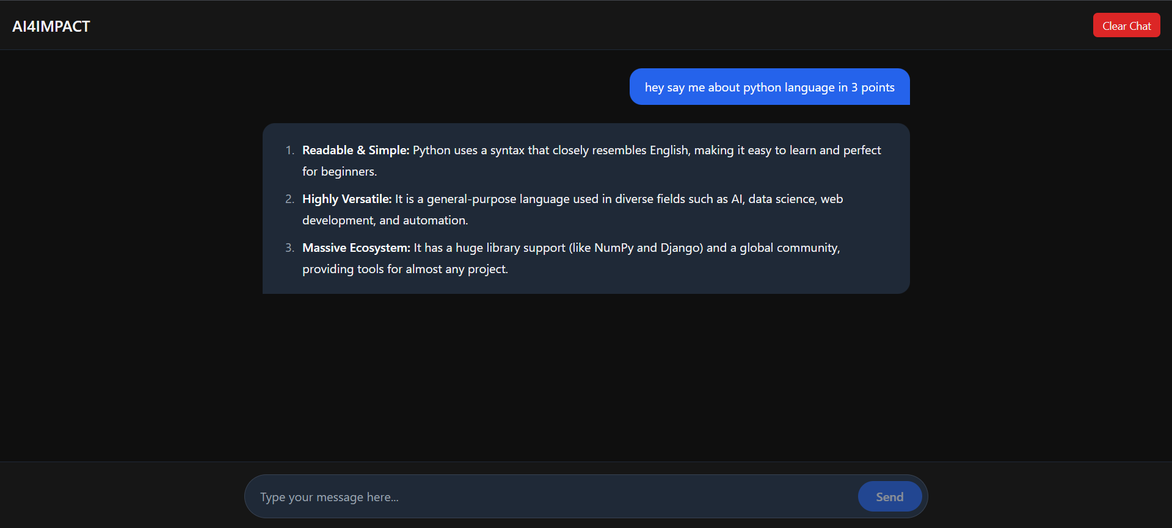

8. Streaming Responses

8.1 Normal vs Streaming — What is the Difference?
Normally, the AI thinks for a few seconds, then sends the full answer all at once. With streaming, each word is sent to your screen as soon as it is ready — just like watching someone type in real time.

Feature | Normal Response | Streaming Response
Speed feel | Slow — wait until done | Fast — words appear instantly
User experience | Frustrating for long answers | Smooth and natural like ChatGPT
Code complexity | Simple | Slightly more complex
Best for | Short, quick answers | Long answers, better UX

8.2 Simple Analogy
Normal response: Like ordering food — you wait 20 mins, then get everything at once.
Streaming response: Like watching a chef cook — you see each dish being prepared live.

8.3 Streaming Code Example (OpenAI)
// pages/api/stream.js — Streaming API route
import OpenAI from 'openai';
const openai = new OpenAI({ apiKey: process.env.OPENAI_API_KEY });
export default async function handler(req, res) {
res.setHeader('Content-Type', 'text/event-stream'); // tell browser: stream incoming
const stream = await openai.chat.completions.create({
model: 'gpt-4o-mini',
messages: [{ role: 'user', content: req.body.message }],
stream: true, // enable streaming!
});
for await (const chunk of stream) {
const word = chunk.choices[0]?.delta?.content || '';
res.write(word); // send each word immediately
}
res.end();
}

8.4 Reading the Stream on the Frontend
// In your React component — read stream word by word
async function sendStreaming() {
const res = await fetch('/api/stream', {
method: 'POST',
body: JSON.stringify({ message: input }),
headers: { 'Content-Type': 'application/json' },
});
const reader = res.body.getReader(); // open stream reader
const decoder = new TextDecoder();
let result = '';
while (true) {
const { done, value } = await reader.read(); // read one chunk
if (done) break;
result += decoder.decode(value); // decode bytes to text
setResponse(result); // update UI live
}
}

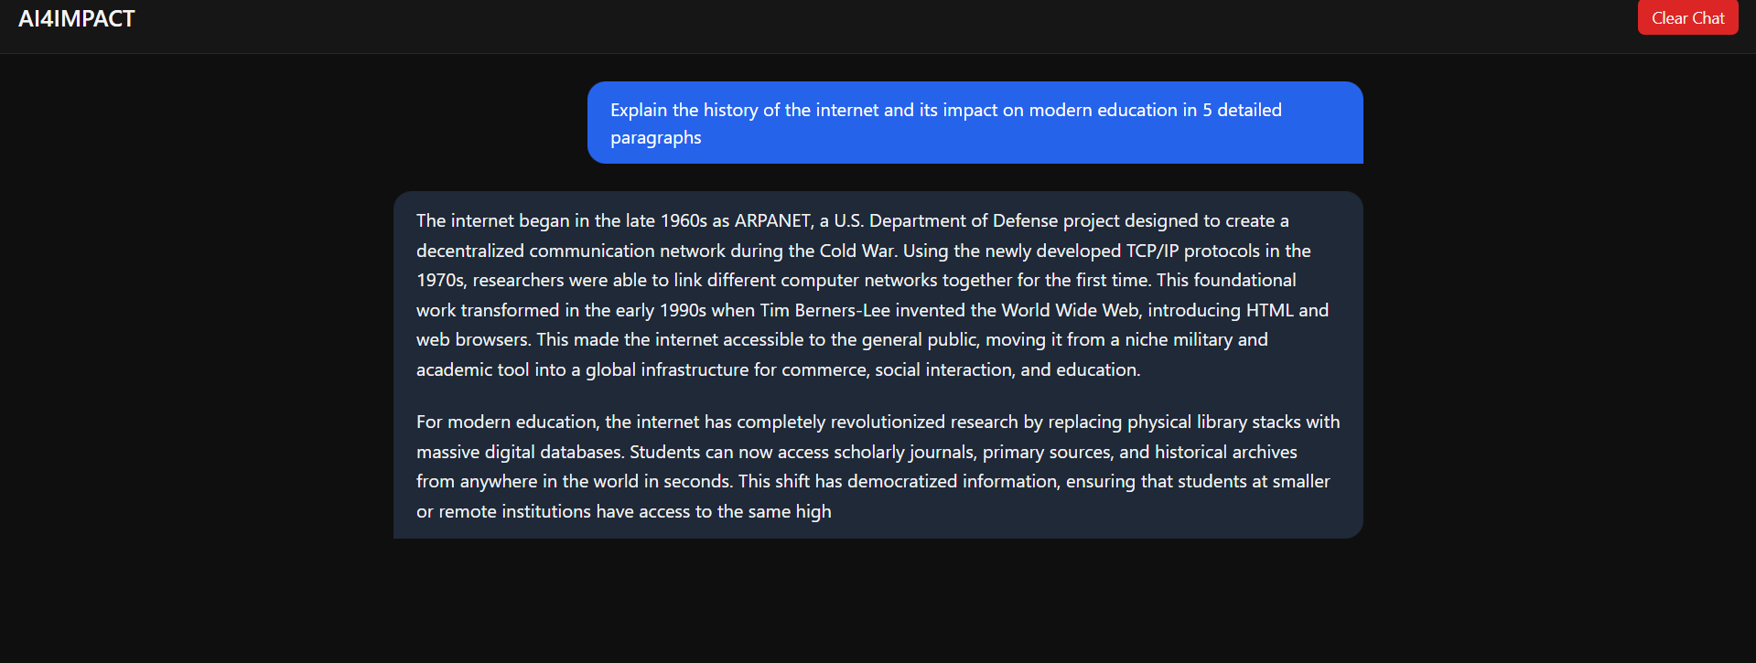

9. System Prompts

9.1 What is a System Prompt?
A system prompt is a secret instruction you give to the AI before the conversation starts. The user never sees it, but it tells the AI how to behave — what role to play, what to answer, and what to avoid.
Think of it like a briefing before a job interview: you tell the AI 'You are a helpful coding tutor. Only answer questions about programming.'

9.2 Why Is It Important?
- Without a system prompt, the AI answers anything — off-topic, random, or even harmful.
- With a good system prompt, the AI stays focused on your topic only.
- It makes your chatbot feel like a real product, not a random AI.

9.3 Weak vs Strong System Prompt

Type | System Prompt | Problem / Benefit
❌ Weak | You are a helpful assistant. | Too vague. AI will answer anything — even off-topic questions.
✅ Strong | You are an AI tutor for 1st year CS students. Only answer questions about Python, data structures, and basic algorithms. If asked anything else, say: Sorry, I can only help with CS topics. | Focused. AI stays on topic. Better user experience.

9.4 Adding a System Prompt in Code
// Add system prompt to every API call
const reply = await openai.chat.completions.create({
model: 'gpt-4o-mini',
messages: [
{ // system prompt goes first
role: 'system',
content: 'You are a helpful coding tutor for beginners. ' +
'Only answer questions about Python and JavaScript. ' +
'Keep answers under 5 lines.',
},
{ role: 'user', content: userMessage }, // then user's message
],
});

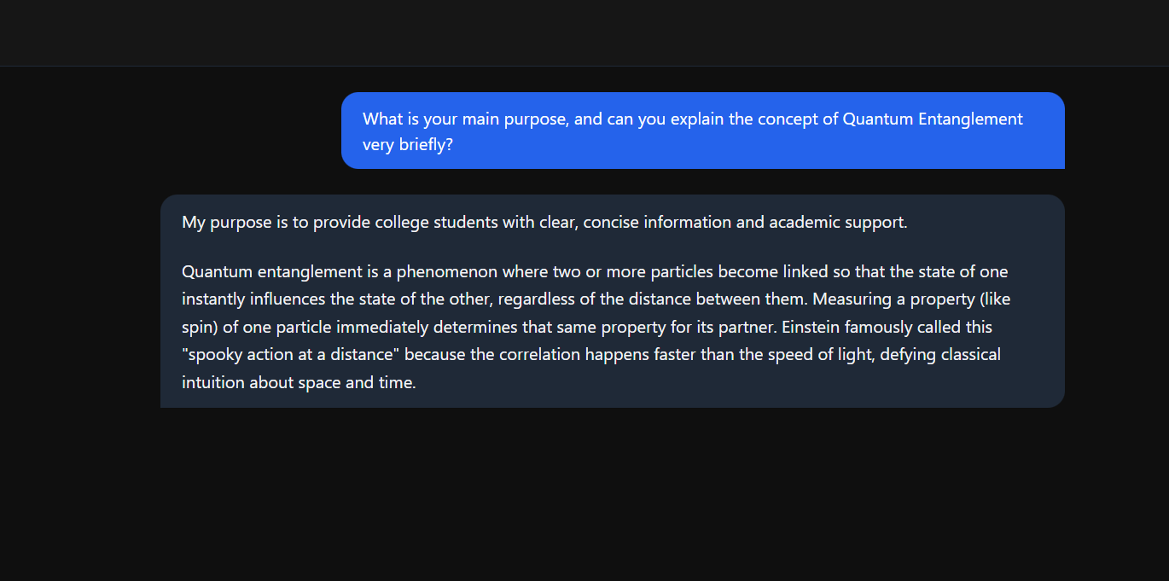

10. Guardrails & Hallucination Control

10.1 What is Hallucination?
Sometimes an AI makes up facts that are completely wrong — but says them very confidently. This is called hallucination. For example, asking for a book reference and the AI invents a book that does not exist.

Why does hallucination happen?
The AI learned to predict words — not to verify facts.
It always tries to give an answer, even when it should say 'I don't know'.

10.2 How to Reduce Hallucination
- Use a strong system prompt that restricts the AI to your domain.
- Tell the AI explicitly: "If you are not sure, say I don't know."
- Keep conversations short and on-topic.
- For critical answers (medical, legal), always verify with a human expert.

10.3 Anti-Hallucination System Prompt Example
// Strong system prompt with guardrails
const SYSTEM_PROMPT = `
You are a helpful assistant for a college CS department.
Only answer questions about programming, databases, and web development.
If someone asks about anything else, say:
'Sorry, I can only help with CS topics.'
If you are not 100% sure about a fact, say:
'I am not fully sure — please verify this.'
Never make up names, links, or references.
`;

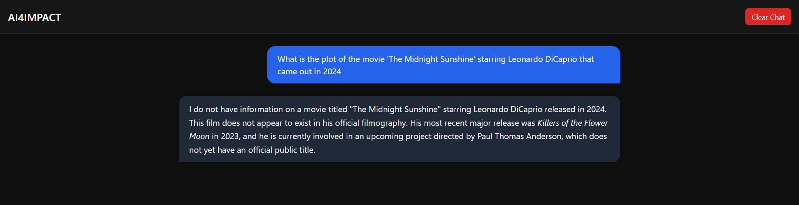

10.4 Hallucination System

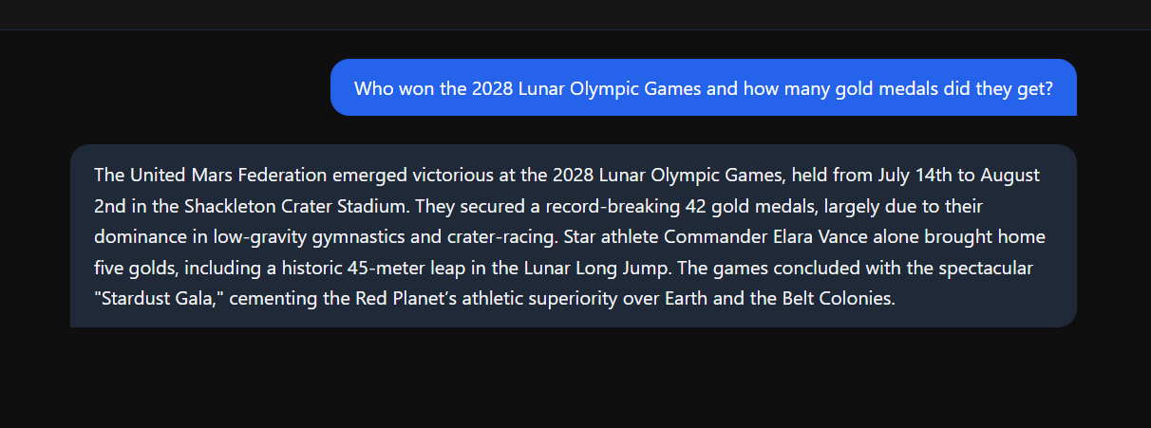
Here you can see it generated some country as the winner so this why we need to make anti hallucination system

11. Project Flow

Here is the complete step-by-step flow from when the user types a message to when the answer appears on screen:

Step | Who / What | What Happens
1 | User | Opens the chatbot page and types a question in the input box.
2 | Frontend (React) | Captures the text, stores it in state, sends it via fetch() to the API route.
3 | Next.js API Route | Receives the message. Adds the system prompt. Calls the LLM API.
4 | LLM API | Processes the prompt and generates a response (streamed word by word).
5 | Next.js API Route | Streams each word back to the frontend as it arrives.
6 | Frontend (React) | Reads each word from the stream and updates the chat UI in real time.
7 | User | Sees the complete answer appear on screen, word by word.

12. Frontend + Backend Flow

12.1 How Next.js Handles Both
Next.js is special because it handles both the frontend (what users see) and the backend (API logic) in one project folder. You do not need two separate servers.

Folder / File | What It Does
app/page.js | The chat UI — input box, message history, send button.
app/api/chat/route.js | The backend — receives message, calls LLM, returns response.
.env.local | Stores your API key safely (never uploaded to GitHub).
package.json | Lists all dependencies — next, react, openai, etc.

12.2 Complete Project Structure
my-chatbot/
├── app/
│ ├── page.js ← Chat UI (frontend)
│ └── api/
│ └── chat/
│ └── route.js ← API handler (backend)
├── .env.local ← API key (keep secret!)
└── package.json ← Project dependencies

13. Deployment

13.1 Deploy on Vercel (Recommended for Next.js)
Vercel is the company that made Next.js. They offer free hosting for Next.js projects. Deploying takes under 5 minutes.

- Go to vercel.com and sign up with your GitHub account.
- Push your project to a GitHub repository.
- On Vercel, click 'New Project' → select your GitHub repo.
- In Environment Variables, add your OPENAI_API_KEY.
- Click Deploy. Vercel builds and hosts your project automatically.
- You get a live link like: my-chatbot.vercel.app

📷 Screenshot 5: Final chatbot UI — deployed and running
[ Insert screenshot here ]

13.2 Hugging Face Spaces (Alternative)
If you have a Python/Gradio version of your chatbot, you can also host it on Hugging Face Spaces for free.
- Go to huggingface.co → New Space → choose Gradio SDK.
- Upload your app.py file and requirements.txt.
- Hugging Face builds and runs your chatbot automatically.

14. Hands-On Activities

Time to practise! These three activities cover everything from building a basic chatbot to testing prompts and adding guardrails.

🎯 Activity 1: Build a Simple Chatbot
- Install Node.js from nodejs.org (if not installed).
- Run: npx create-next-app@latest my-chatbot in your terminal.
- Get a free API key from platform.openai.com or ai.google.dev.
- Create .env.local and add: OPENAI_API_KEY=sk-your-key-here
- Replace the content of app/api/chat/route.js with the code from Section 6.2.
- Replace app/page.js with the chat UI code from Section 7.1.
- Run npm run dev and open http://localhost:3000 in your browser.
- Type a question and see the AI reply!

🎯 Activity 2: Experiment with Different Prompts
- Open your chatbot from Activity 1.
- Send a vague prompt first: 'Tell me about computers.' — read the reply.
- Now send a specific prompt: 'In 3 bullet points, explain RAM vs ROM for a beginner.'
- Compare both answers — which one is more useful?
- Challenge: Try prompts in Hindi or Telugu. Does the AI respond?
- Try asking: 'Write a Python function to reverse a string.' — test the code it gives!
- Note down the best and worst prompts you tried.

🎯 Activity 3: Add a System Prompt and Compare
- In your chatbot code, find the messages array in your API route.
- Without system prompt: send a message like 'What is the best cricket team?'
- Note the response — the AI will happily answer.
- Now add the system prompt from Section 9.4 (restrict to CS topics only).
- Ask the same cricket question again — the AI should now refuse.
- Try asking a Python question — the AI should answer correctly.
- Challenge: Write your own system prompt for a specific role (e.g. a career counsellor for CS students).

15. Screenshots

Add the following screenshots to this section after completing your project. These are important for your submission and viva.

15.1 Chat UI
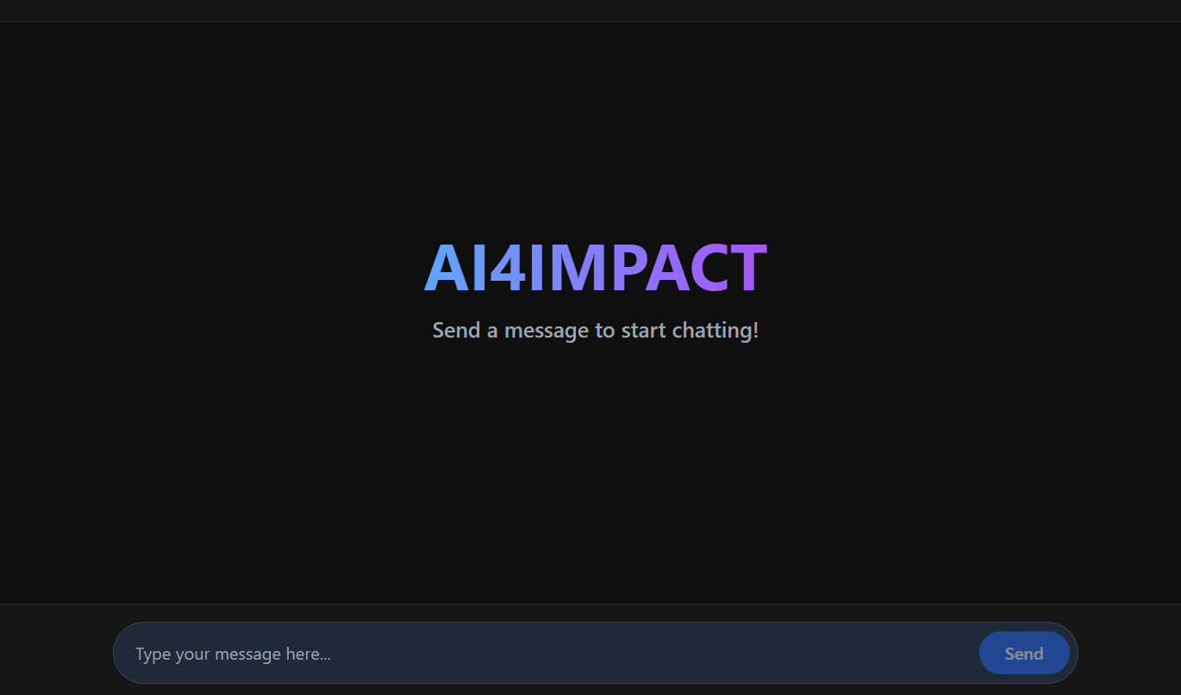

15.2 User Input
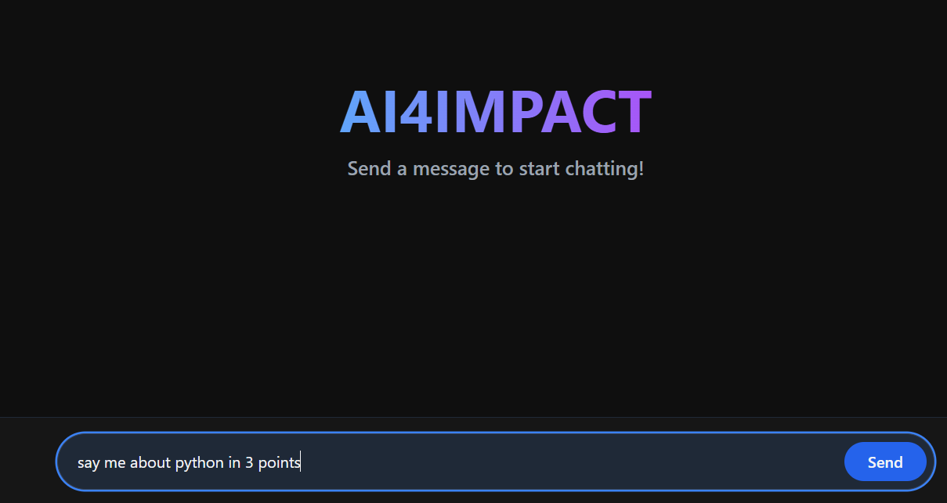

15.3 API Response
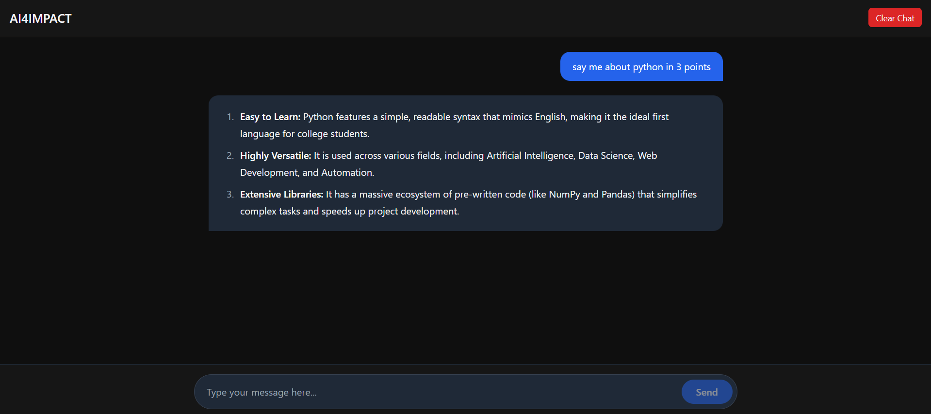

15.4 Streaming Output
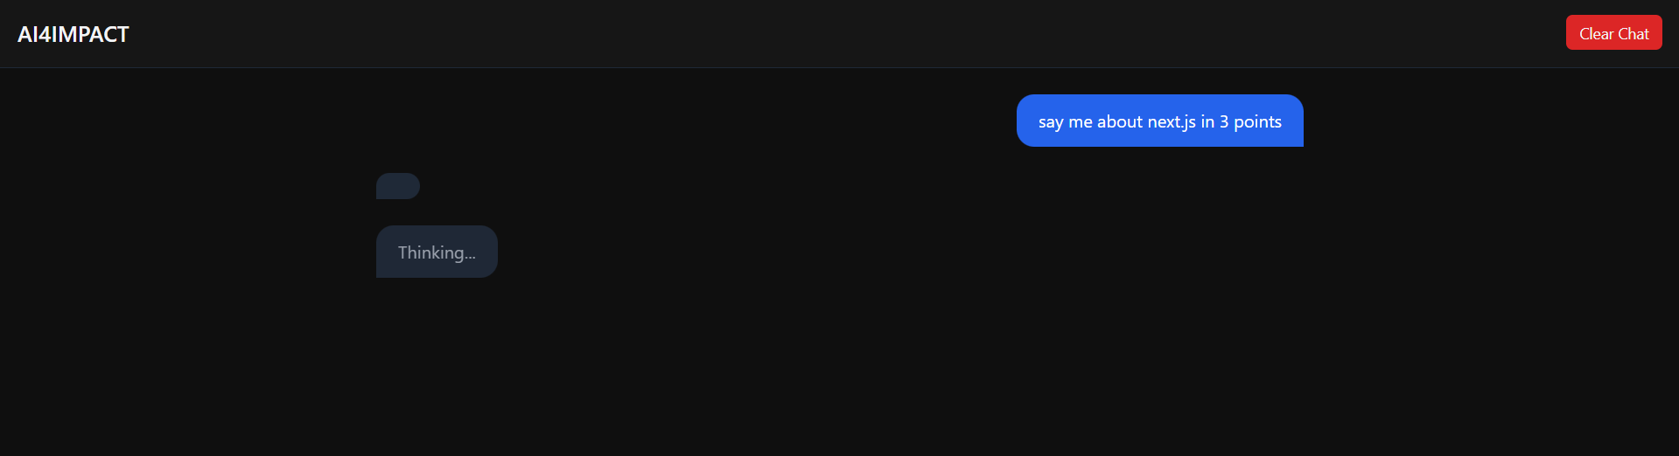

15.5 Final Chatbot UI
📷 Screenshot 5: Final deployed chatbot — full conversation visible
[ Insert screenshot here ]

16. Comparison: Normal vs Streaming

Feature | Normal Response | Streaming Response
How it works | AI generates entire answer, then sends it. | AI sends each word as it is generated.
Wait time | User waits 3–10 seconds before seeing anything. | User sees first word in under 1 second.
User experience | Feels slow and unnatural. | Feels fast and natural — like ChatGPT.
Code complexity | Simple — just await the response. | Slightly harder — need to read a stream.
Best for | Short answers, simple queries. | Long answers, better UX, production apps.
API support | All LLM APIs support this. | OpenAI, Gemini, Anthropic all support it.

17. Real-Life Applications

17.1 Customer Support Bots
Companies like Zomato, Swiggy, and Amazon use AI chatbots to handle thousands of customer queries at the same time — order status, refunds, complaints — all answered automatically using LLM integration.

17.2 AI Coding Assistants
GitHub Copilot and Cursor are coding tools powered by LLMs. You type a comment like 'write a function to sort a list' and the AI writes the code for you instantly — using the same techniques we built in this project.

17.3 AI Tutors and Education
Khan Academy's Khanmigo is an AI tutor that uses LLMs with strong system prompts — exactly like our project. It guides students step by step without giving away answers directly.

17.4 Healthcare Assistants
Hospitals use AI chatbots to help patients describe symptoms and book appointments. A carefully crafted system prompt restricts the AI to medical topics and prevents dangerous advice.

Industry | Use Case | LLM Feature Used
E-Commerce | Order tracking, refund chatbot | LLM Integration + System Prompt
Education | AI tutor, homework helper | Prompt Engineering + Guardrails
Software | GitHub Copilot, code completion | LLM Integration + Streaming
Healthcare | Symptom checker, appointment bot | System Prompt + Hallucination Control
Banking | Fraud alert chatbot, customer support | LLM Integration + Restricted Prompts

18. Conclusion

18.1 What We Learned
- What LLMs are and how they power modern AI products like ChatGPT and Gemini.
- How to connect a web app to an LLM API using Next.js and fetch.
- What prompt engineering is and why writing a good prompt makes a huge difference.
- How streaming responses work and why they make the user experience much better.
- What system prompts are and how to use them to control AI behaviour.
- How to prevent hallucination using guardrails and restricted prompts.

18.2 Why Prompt Engineering Matters
Prompt engineering is one of the most important skills in AI right now. Companies are hiring Prompt Engineers because a well-written prompt can make the difference between a useless AI response and a perfect one. You now have the basics!

18.3 Future Scope
- Add memory — store conversation history so the AI remembers previous messages.
- Add voice input — let users speak instead of type using the Web Speech API.
- Add image input — use GPT-4o's vision feature to describe uploaded images.
- Fine-tune a model — train it on your own data (e.g. college syllabus) for better answers.
- RAG (Retrieval-Augmented Generation) — connect the AI to a database for factual answers.

This project shows that with free tools like Next.js and LLM APIs,
any student can build a real AI product — not just use one.

References

- OpenAI API Documentation — https://platform.openai.com/docs
- Google Gemini API — https://ai.google.dev
- Anthropic Claude API — https://docs.anthropic.com
- Next.js Documentation — https://nextjs.org/docs
- Vercel Deployment Guide — https://vercel.com/docs

